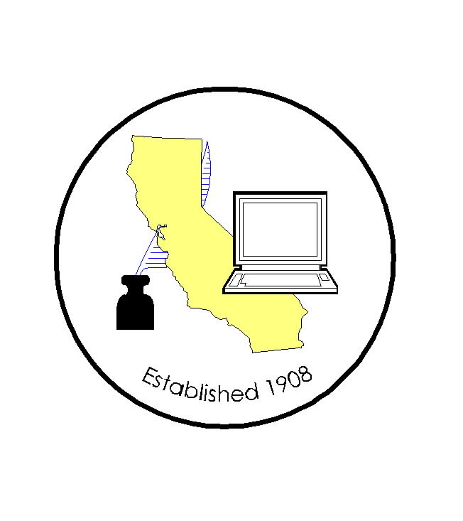
CALIFORNIA ASSOCIATION OF

CLERKS AND ELECTION OFFICIALS

PLEASE NOTE: REGISTRATION IS NOW BEING HANDLED BY
NEAL KELLEY, ORANGE COUNTY ROV*

DATE: December 11, 2007
TO: CACEO Members, Legislative Committee
FROM: *Neal Kelley, Orange County Registrar of Voters
SUBJECT: CACEO LEGISLATIVE COMMITTEE MEETING

DATE: Friday, January 4, 2008

TIME: 9:00 a.m. – 3:00 p.m.

LOCATION: Sheraton Gateway (LAX) Phone: (888) 627-7104
6101 West Century Blvd. (310) 642-1111
Los Angeles, CA 90045 Rate: $110 sgl/dbl
Deadline for group rate: December 13, 2007
SUBCOMMITTEES: Thursday, January 3, 2007
(contact Subcommittee Chairs for additional information)

REGISTRATION
Registration deadline: December 28, 2007
No refunds will be provided after this date

Name: ____________________________________________________

County/City: ____________________________________________________

Fee enclosed: Member: $55.00 (payment received by Dec. 28th)
Auditor cutting check
$105.00 (payment received after Dec. 28th)
$275.00 (payment for year; due Dec. 28th)

Non-Member: $105.00 (payment received by Dec. 28)
$155.00 (payment received after Dec. 28)

Check payable to: California Association of Clerks and Election Officials

*Return to: Neal Kelley, Orange County Registrar of Voters
P. O. Box 11298
Santa Ana, CA 92711-1298
phone: (714) 567-7620
fax: (714) 567-7627
e-mail: linda.strickland@rov.ocgov.com

